Java Basic Assignment questions
1. Write a Java program to declare two integers and print their sum, difference, product, and quotient.
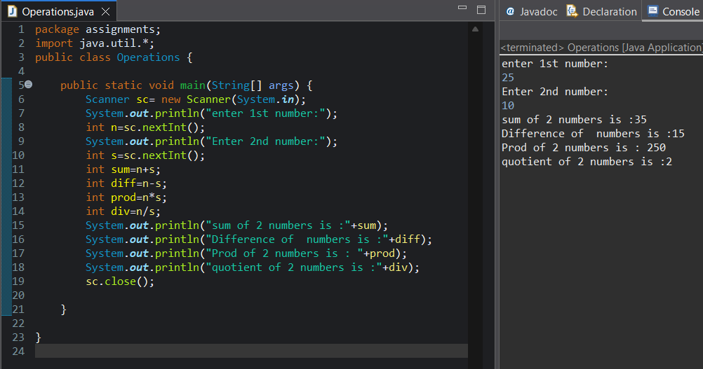
2. Write a program to swap two numbers:
o Using a temporary variable
o Without using a temporary variable
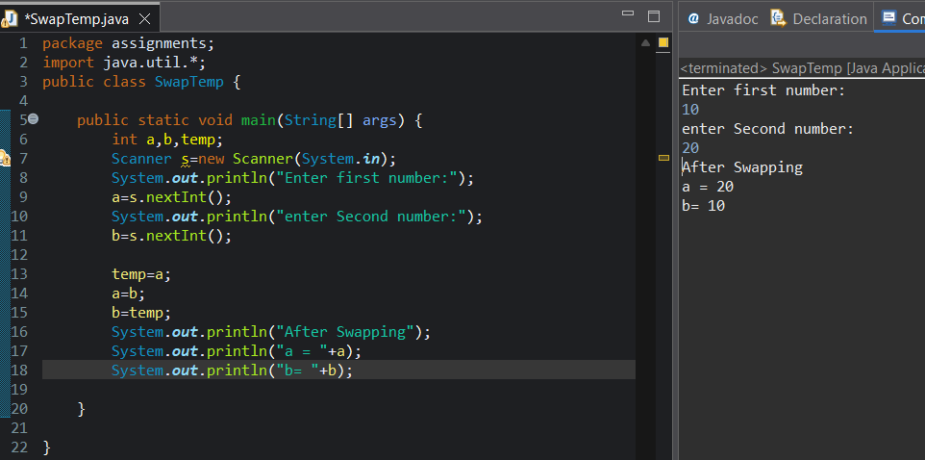
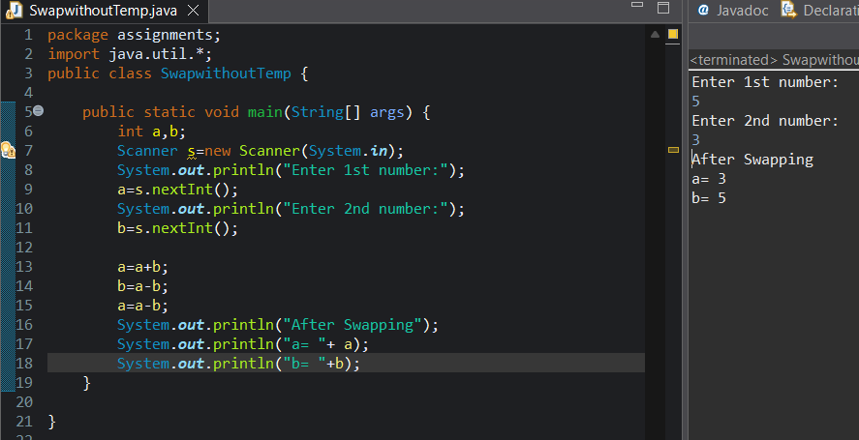
3. Write a program to calculate simple interest.
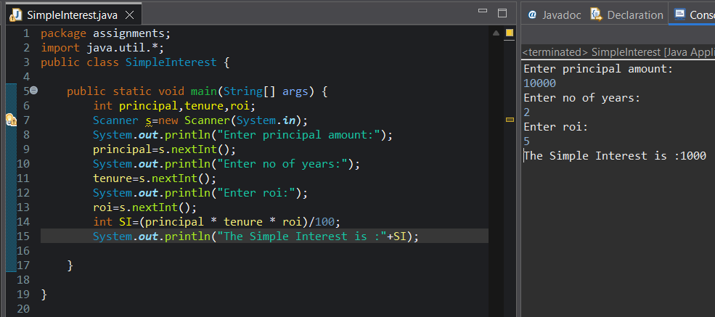
4. Write a program to calculate area and perimeter of a rectangle.
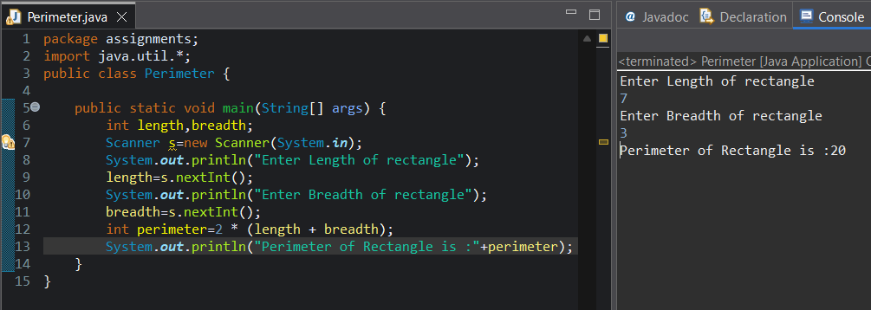

5. Write a program to convert:
o Celsius to Fahrenheit
o Kilometers to Miles
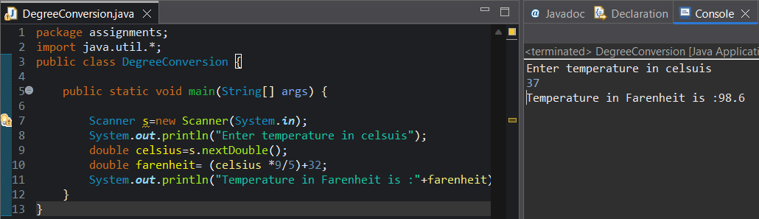
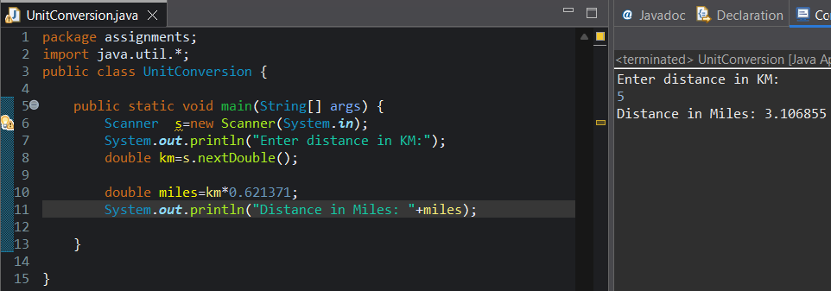
6. Write a program to check whether a number is positive, negative, or zero.
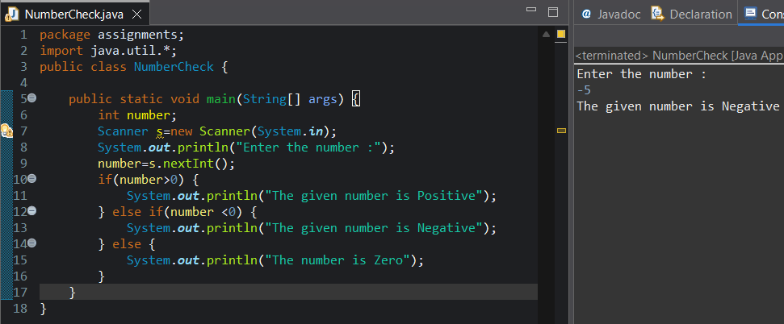

7. Write a program to check whether a number is even or odd.
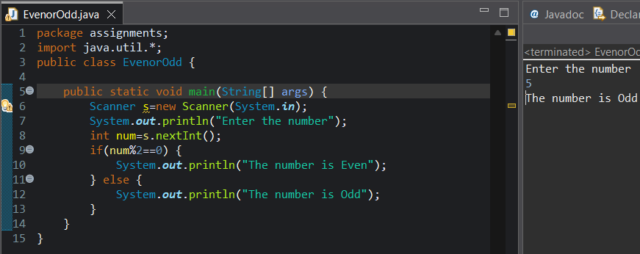
8. Write a program to check whether a year is a leap year.
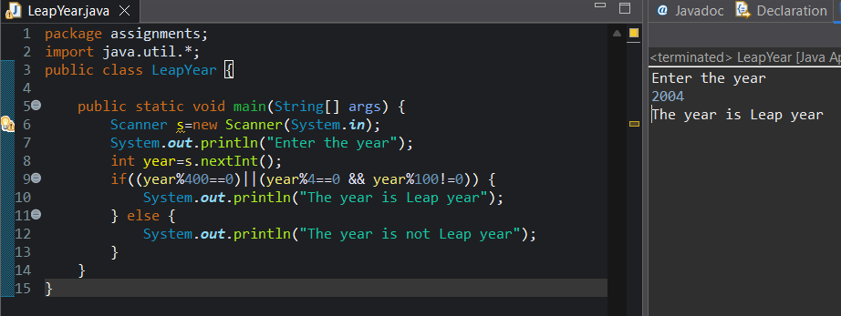
9. Write a program to find the largest of three numbers.
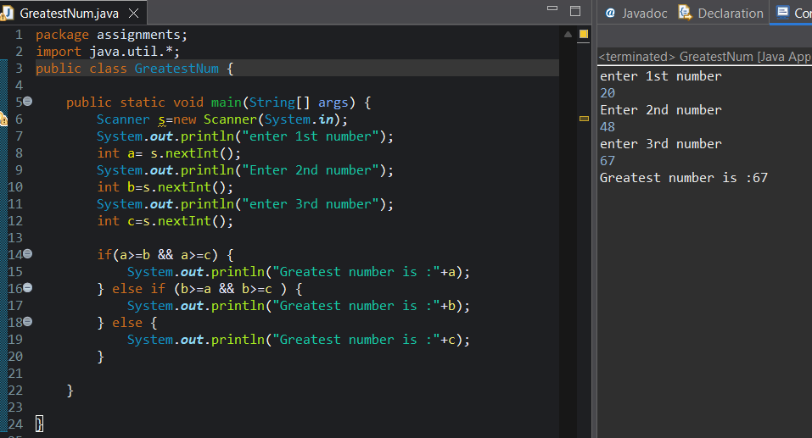
10. Write a program to calculate student grade based on marks:
o ≥ 90 → A
o ≥ 75 →B
o ≥ 60 → C
o Else → Fail
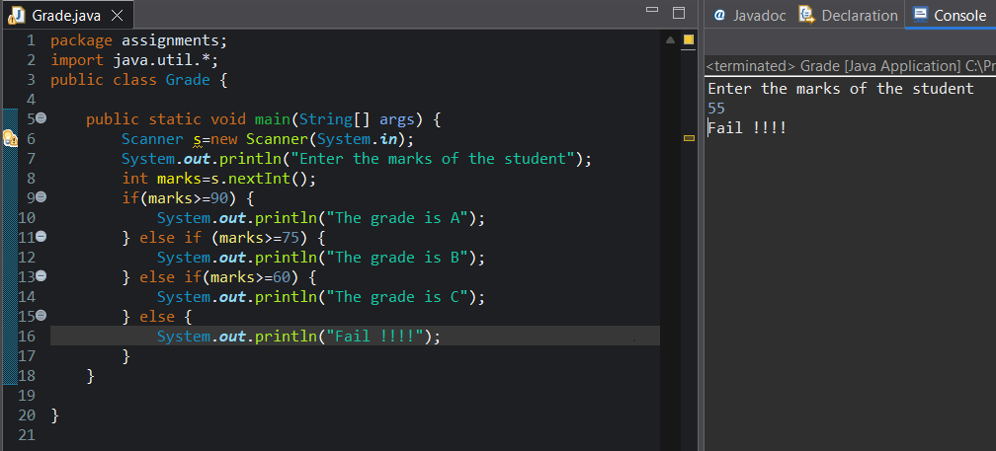
11. Write a program using switch-case to create a simple calculator.
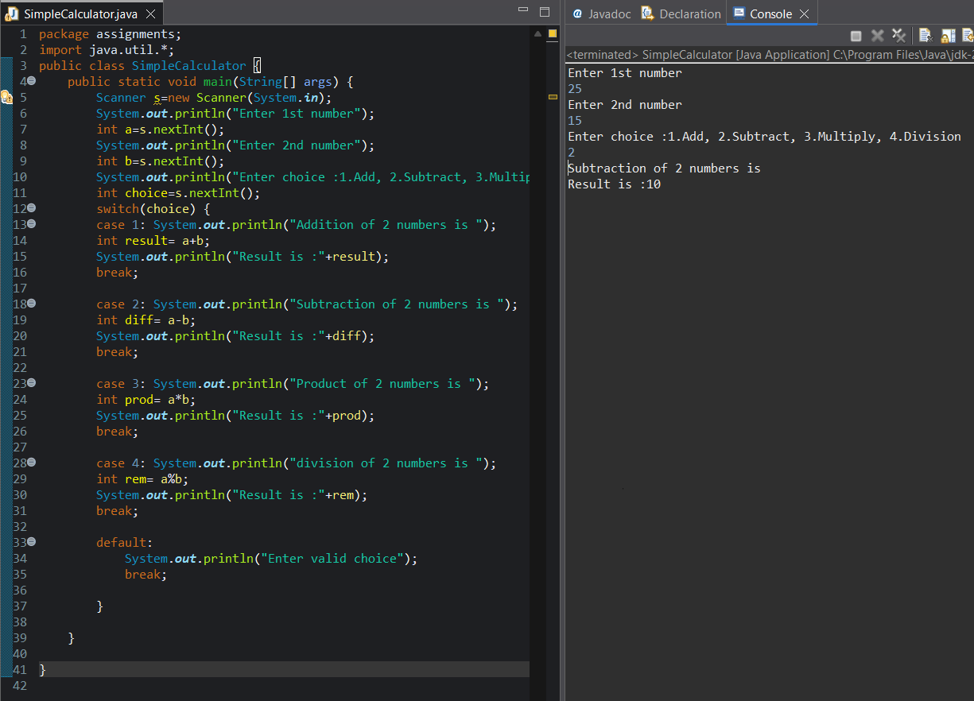

12. Print numbers from 1 to 100.
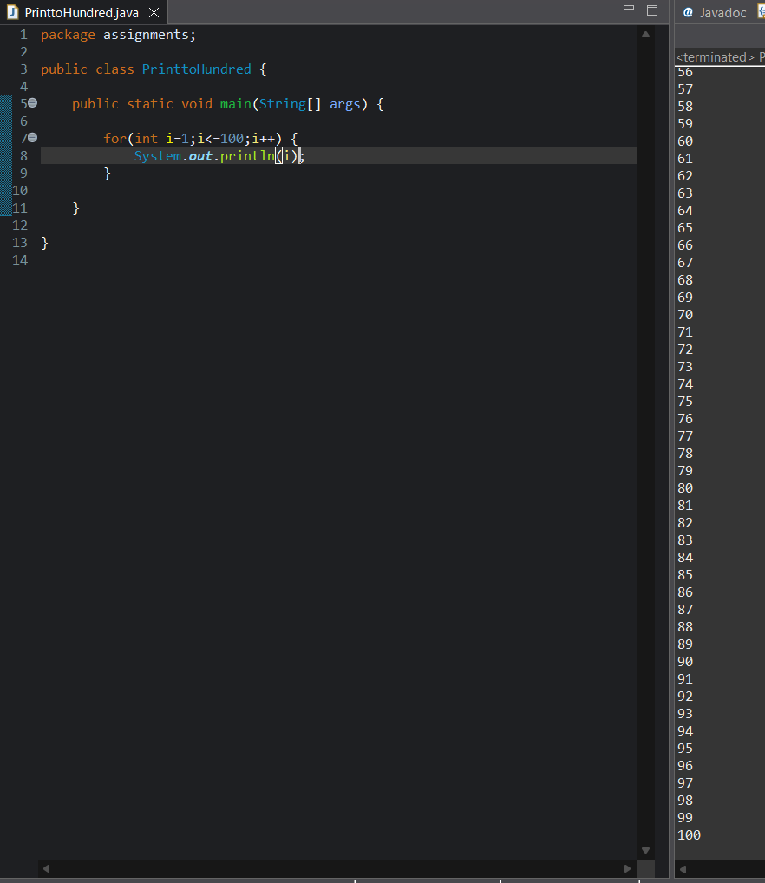

13. Print all even numbers between 1 and 50.
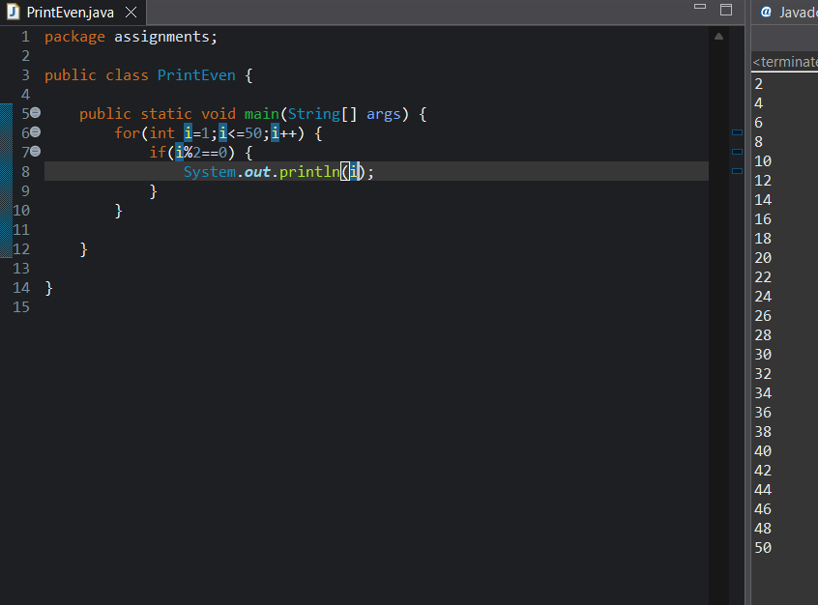
14. Write a program to calculate factorial of a number.
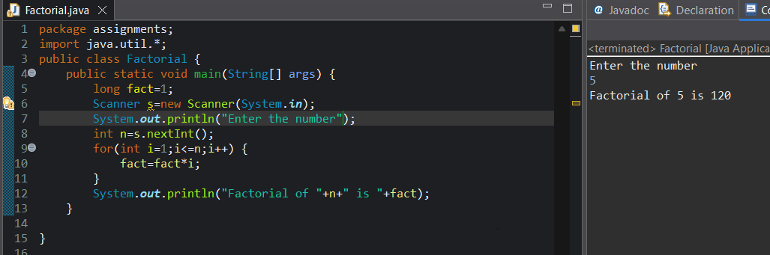

15. Write a program to print the multiplication table of a given number.
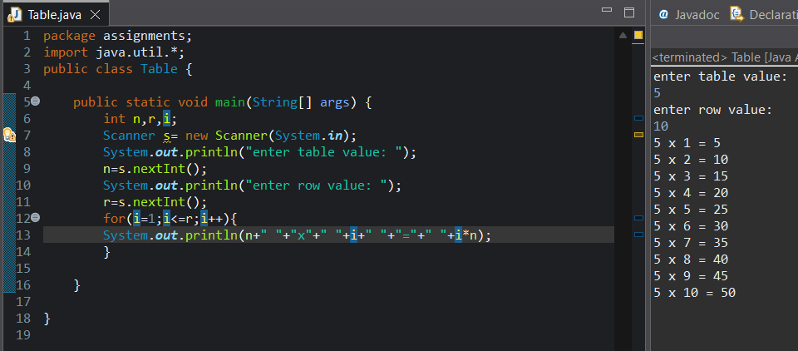
16. Write a program to calculate the sum of digits of a number.
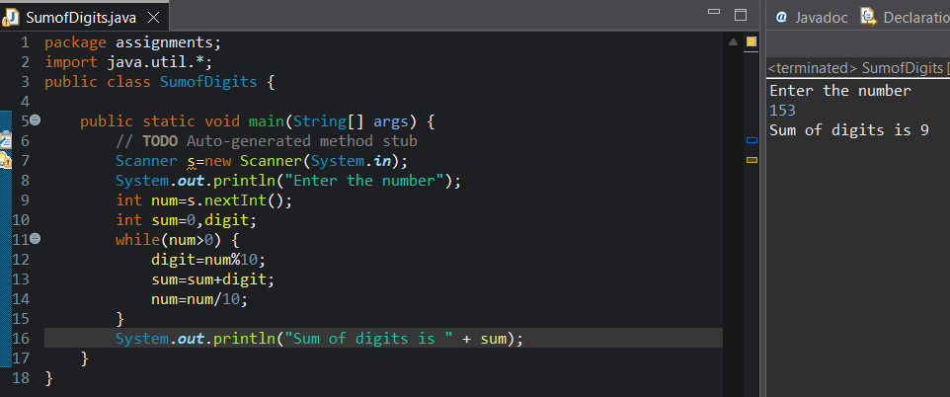
17. Write a program to reverse a number.
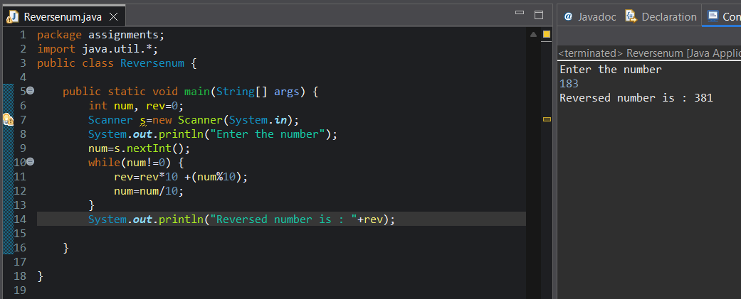

18. Write a program to check whether a number is a palindrome.
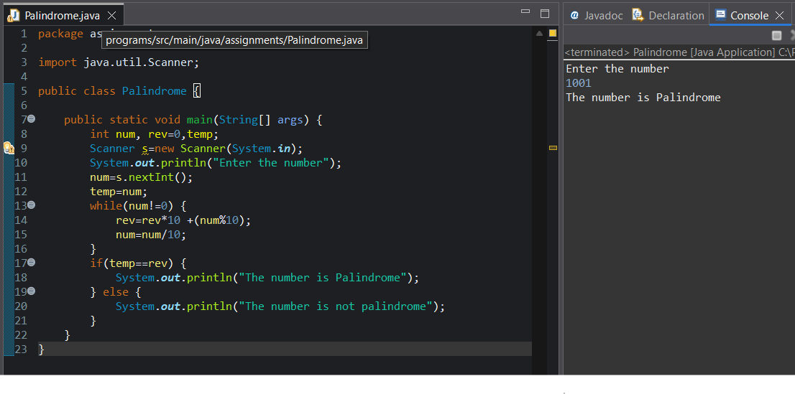19. Write a program to print Fibonacci series up to n terms
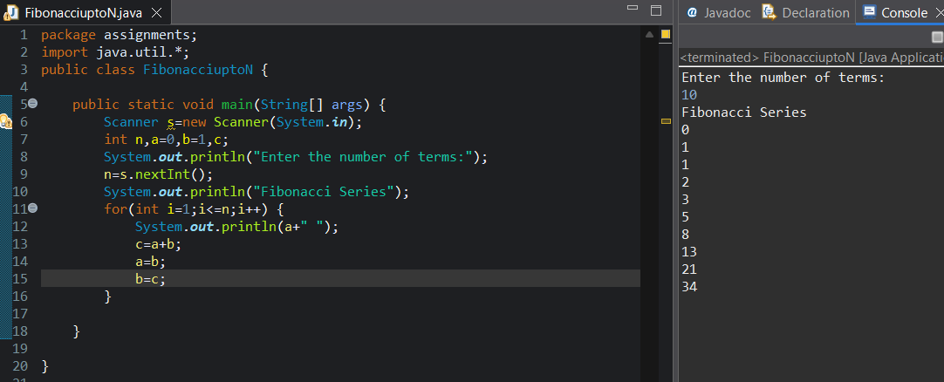
20. Write a program to check whether a number is prime.
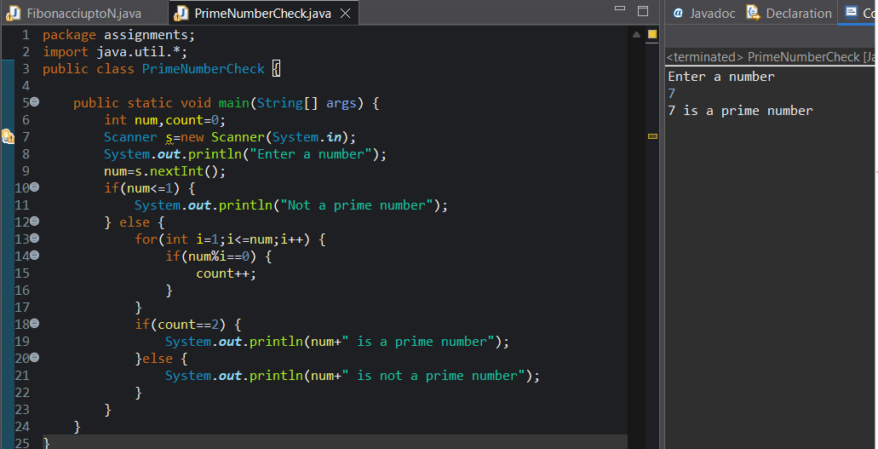
21. Write a program to store 5 integers in an array and print them.
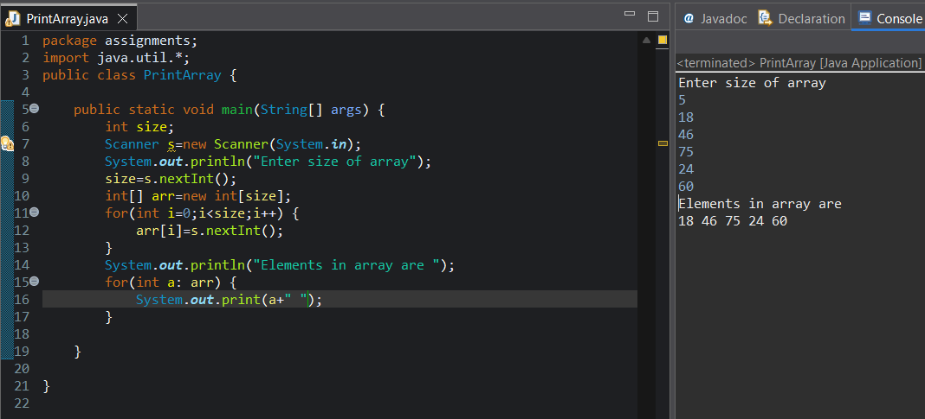
22. Write a program to find the sum and average of array elements.
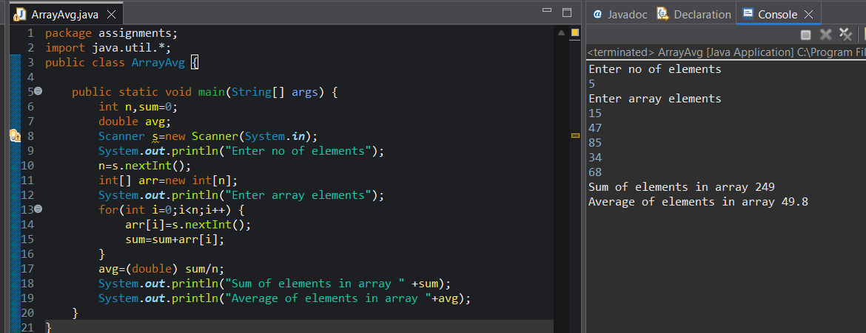
23. Write a program to find the largest and smallest element in an array.
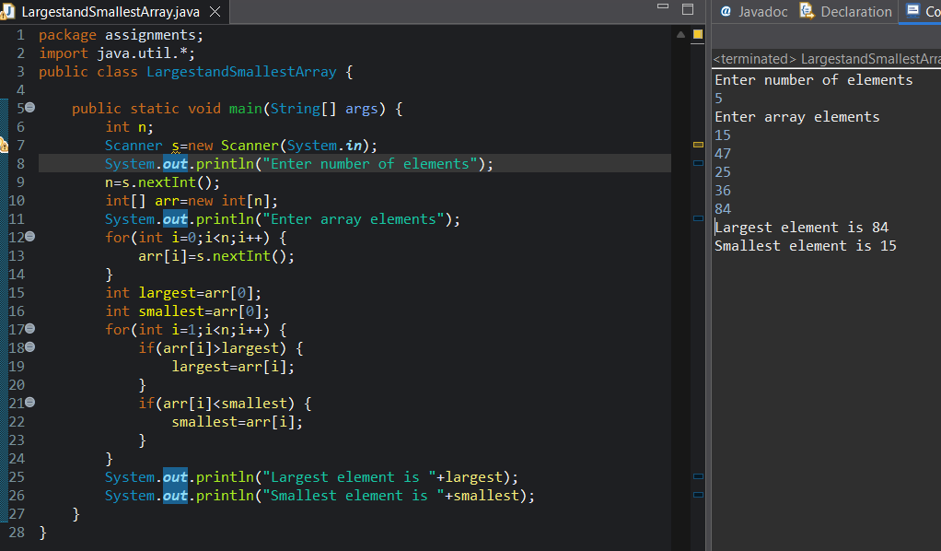

24. Write a program to count even and odd numbers in an array.
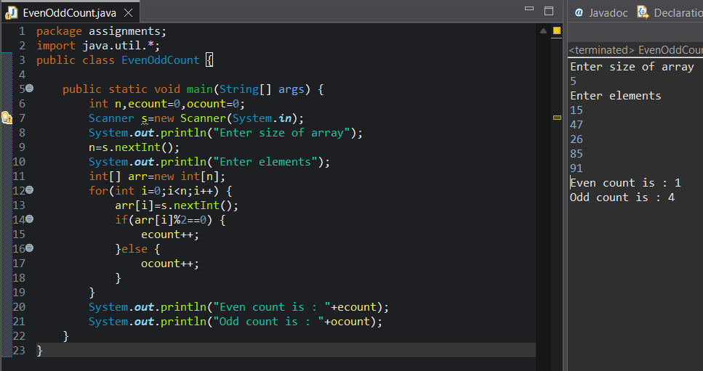
25. Write a program to reverse an array.
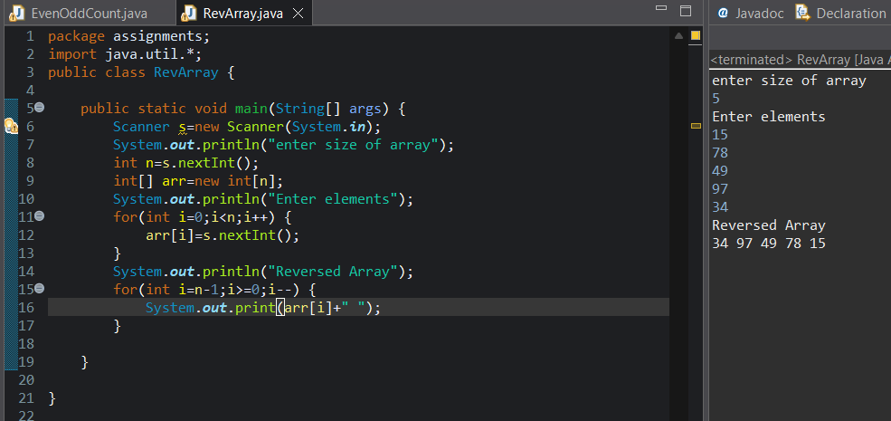
26. Write a program to search an element using: • Linear Search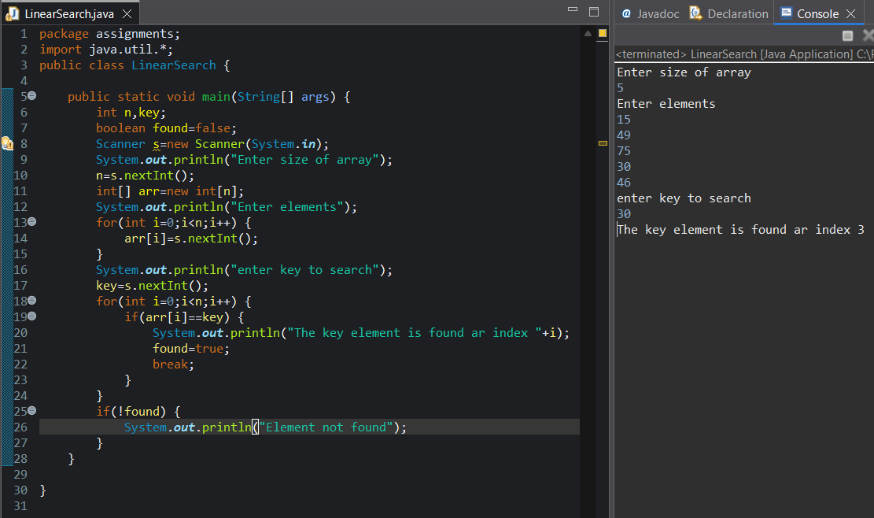
27. Write a program to sort an array in ascending order.
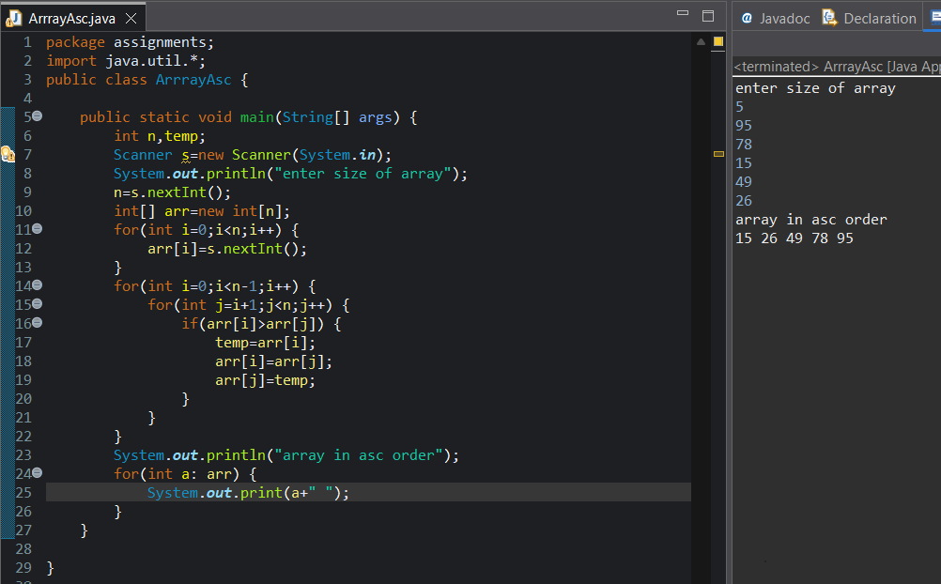

28. Write a program to count vowels and consonants in a string.
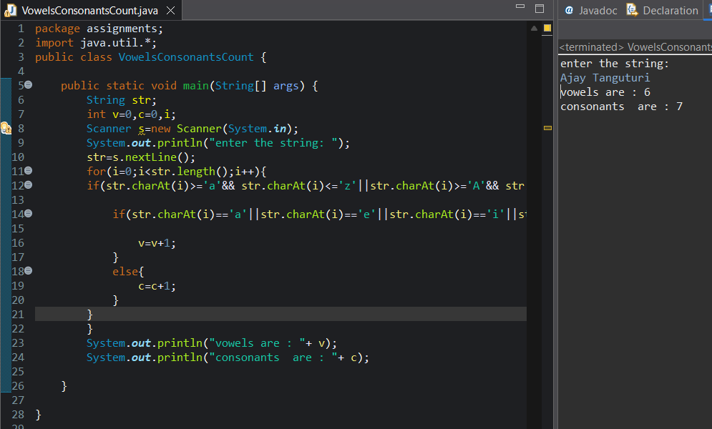
29. Write a program to reverse a string. 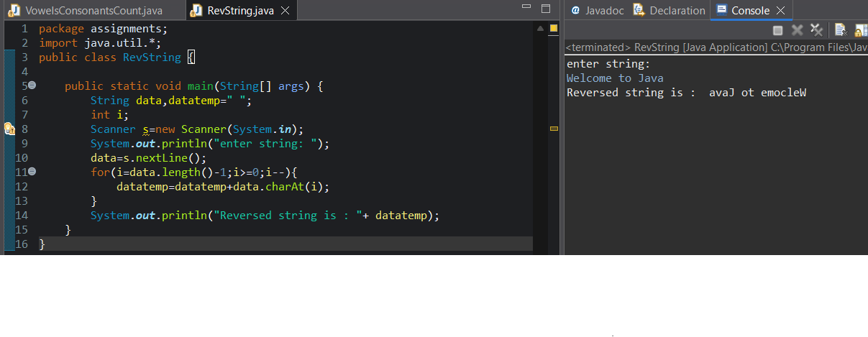

30. Write a program to check whether a string is a palindrome.
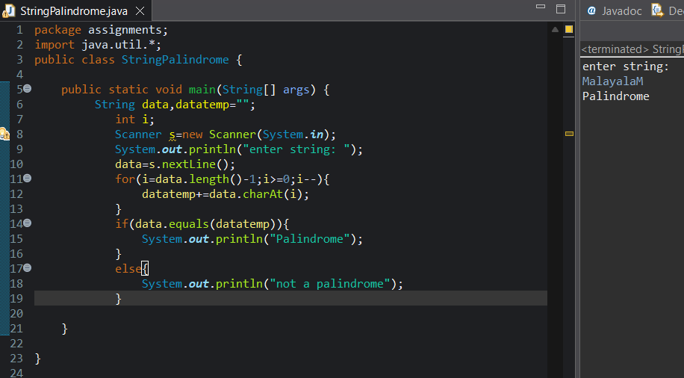
31. Write a program to count number of words in a sentence.
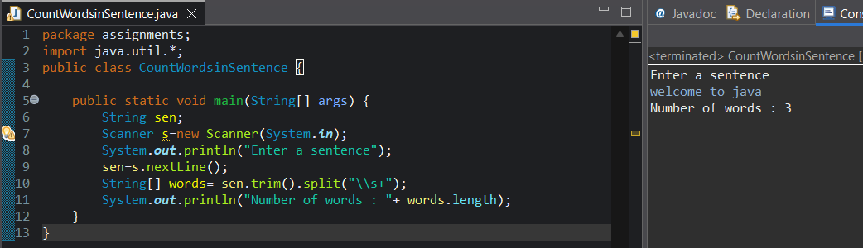
32. Write a program to find duplicate characters in a string.
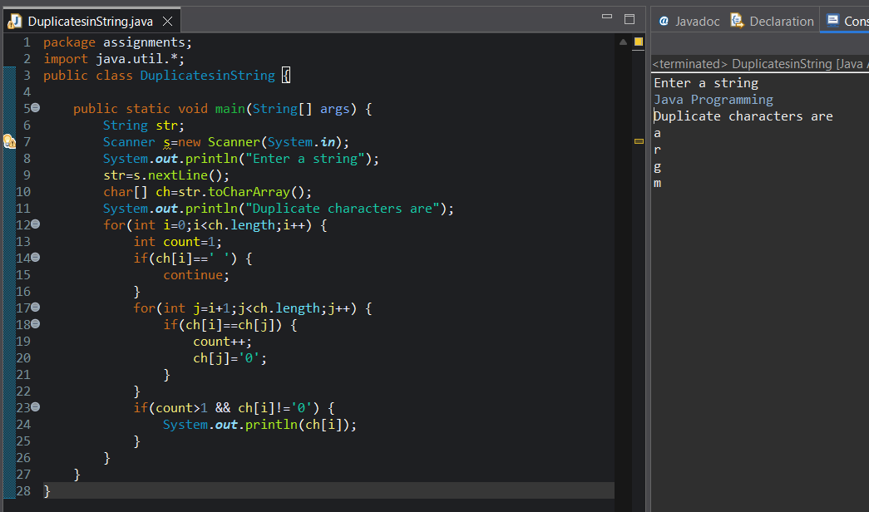
33. Write a program to convert:
• Lowercase to Uppercase
• Uppercase to Lowercase
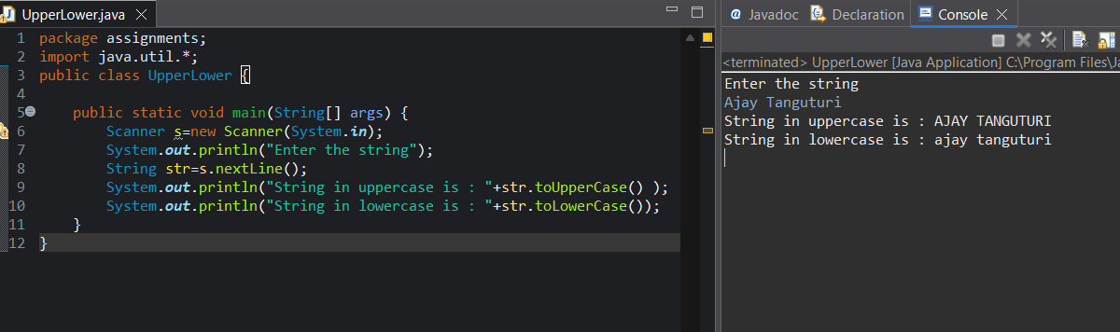
34. Write a program with a method to check even or odd.
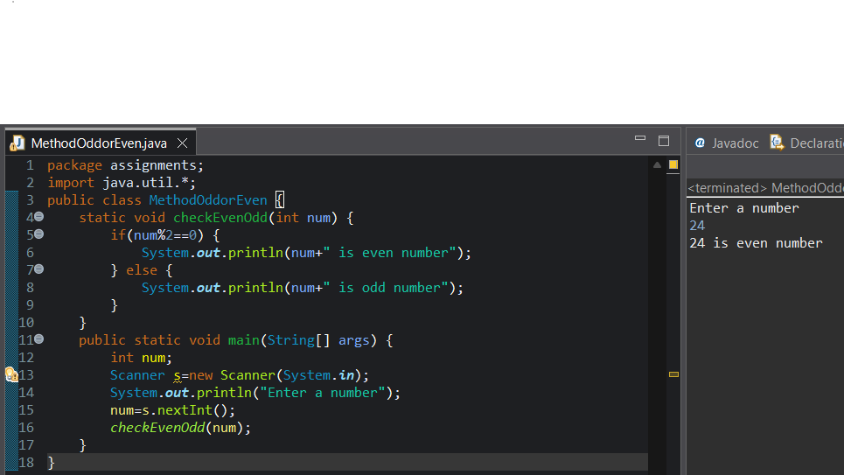
35. Write a method to find factorial of a number.
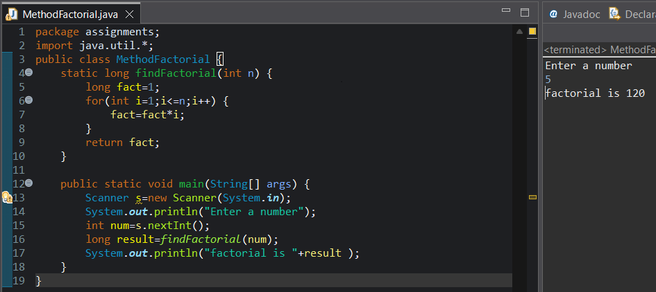

36. Write a method to check prime number.
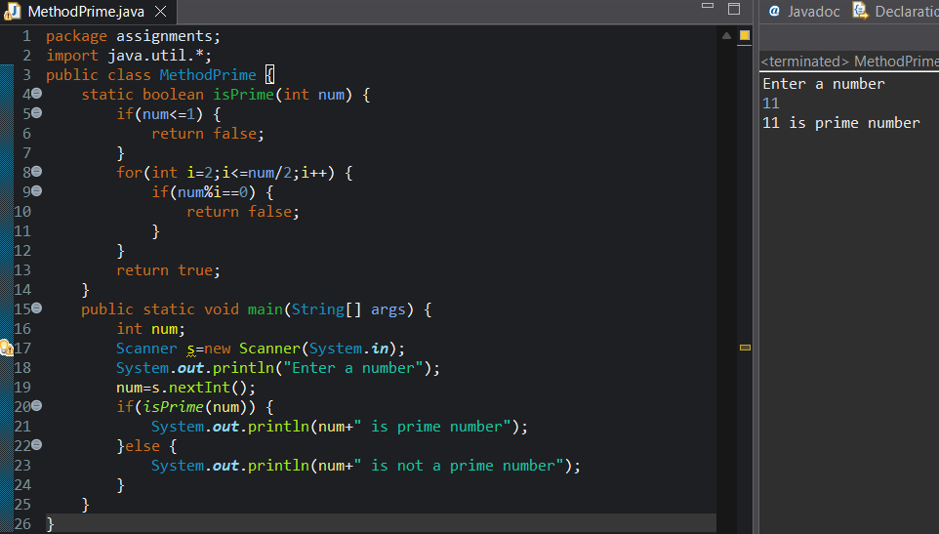
37. Write a method to find maximum of two numbers.
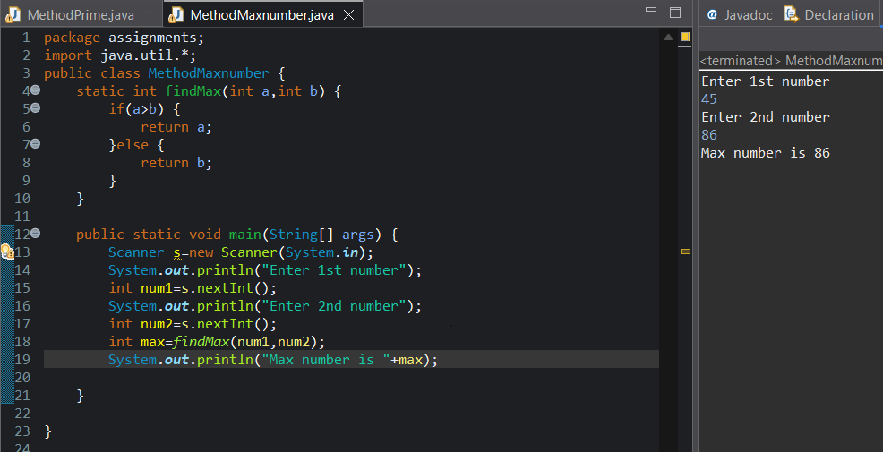

38. Write a method to calculate simple interest.
